**Hochschule Flensburg Wind Energy Technology Institude**

University of Applied Science Research on wind Energy

**Advance Wind Farm Development, WiSe 2024/25**

Master’s degree in Wind Engineering, Flensburg, Germany

**Submitted by**

Karan Soni (760153)

Mostafa Mozafary (750247)

Rahul Patil (750532)

**Supervising Professors:**

Prof. Dipl.-Met. Eva Maria Nikolai

Prof. Dr. Jörg Winterfeldt

**Exam Date:** 16.01.2025

**Date of submission:** 05.02.2025

Table of Contents

List of Figures iii

List of Tables iii

Acronyms iv

1. Introduction and Motivation 1

2. Methodology 2

3. Wind Farm Development 4

3.1 Baseline layout without flicker and noise requirements 5

3.1.1 Layouts of Vestas V150-4.5MW HH125 6

3.1.2 Comparison of different Layout of Vestas V150-4.5MW HH125 6

3.1.3 Layout of Enercon E-147 EP5 E2 5000 HH 126 8

3.1.4 Commercial Evaluation of Wind Farm 8

3.2 Noise and Flicker Compliant Layout 9

3.2.1 Noise 10

3.2.2 Shadow Flicker 13

3.3.3 Bats 14

3.3.4 Commercial Evaluation of Wind Farm 15

4. Recommendations for Future Work 18

5. Conclusion 19

6. References 20

# List of Figures

Figure 3. 1: WTGs area 4

Figure 3. 2: Orography 4

Figure 3. 3: Roughness 4

Figure 3. 4: Long term data ERA5(T) 5

Figure 3. 5: Long term and short term data comparisons 5

Figure 3. 6 MCP output 5

Figure 3. 7: Wind rose 6

Figure 3. 8: Distance circle for wind turbine 6

Figure 3. 9: Six wind turbine of Vestas V150 – 4.5MW HH125 6

Figure 3. 10: Five wind turbine of Vestas V150 – 4.5MW HH 125 6

Figure 3. 11: Wind park result for five Vestas wind turbines 7

Figure 3. 12: Wind park result for six Vestas wind turbines 7

Figure 3. 13: Wind park result for seven Vestas wind turbines 7

Figure 3. 14: Six wind turbine of Enercon E147 EP5 E2 5000 HH 127 8

Figure 3. 15: Residencial and other area near to wind farm area 9

Figure 3. 16: Noice levels Vestas layout 10

Figure 3. 17 : Vestas Noice mode result 11

Figure 3. 18 : First Iteration of Operation modes 11

Figure 3. 19 : Final Iteration with optimized result 11

Figure 3. 20 : Enercon Noice mode result 12

Figure 3. 21: Final Iteration with optimized result for Enercon layout 12

Figure 3. 22 : Noise curtailment 13

Figure 3. 23 Shadow Flicker 13

Figure 3. 24 : Shadow flicker for Vestas layout 14

Figure 3. 25: Shadow flicker for Enercon layout 14

Figure 3. 26 : Implementation of Bat curtailment 15

# List of Tables

Table 3. 1: Commercial Evaluation of six Vestas V150-4.5MW HH125 and Enercon E-147 EP5 E2 5000 HH 127 wind turbines 9

Table 3. 2 : Commercial Evaluation based on Noise modes and bat curtailment 16

Table 3. 3 : Commercial Evaluation based on Noise and bat curtailment 17

# Acronyms

**E** Easting

**N** Northing

**UTM**  Universal Transverse Mercator

**ETRS89** [European Terrestrial Reference System 1989](https://en.wikipedia.org/wiki/European_Terrestrial_Reference_System_1989)

**MW** Mega Watt

**RD**  Rotor Diameter

**LCOE** Levelized Cost of Energy

**NPV** Net Present Value

**IRR**  Internal Rate of Return

**AEP** Annual Energy Production

**WTGs**  Wind Turbine Generators

**Lidar** Light Detection and Ranging

**STATGEN** Stat Generation

**MCP**  Measure-Correlate-Predict

**HH** Hub Height

**MWh** Mega Watt hour

# Introduction and Motivation

This report presents general information on wind farm planning area. The project was developed as part of the exam “Advance Wind Farm Planning” module within the Wind Energy Engineering Master’s Program at the University of Applied Sciences in Flensburg. Wind farm planning is increasing energy production, energy quality as well as reduce structural load. [1]

The shapefile already provided into exam, which shows the wind farm area, including all exclusion zones, so no need to consider distances to roads or boundaries. The tip height is limited to **200 meters**. Lidar measurements were taken at coordinates **548207 E, 6061864 N (UTM ETRS89 Z32).** This report presents wind farm layouts for **Vestas V150-4.5MW** and **Enercon E-147 EP5 E2 5000** turbines, considering maximum hub height limit. The layouts follow a minimum spacing of **5 RD** in the main wind direction and **3.5 RD** perpendicular.

The Objective of this report is to estimate the energy yield for the baseline layout of two turbines, considering losses, without accounting for flicker and noise. The calculations will include the Levelized Cost of Energy (LCOE), Net Present Value (NPV), and Internal Rate of Return (IRR) for each turbine layout. The same calculations will be repeated, this time including flicker, noise, and bat losses. Based on the NPV, the report will identify the best compliant layout. Finally, the **P75** and **P90** Annual Energy Production (AEP) will be calculated for the selected best compliant layout.

Chapter 2 discusses the method used to achieve the objective. Chapter 3 covers our wind farm layout with two types of wind turbines, both with and without requirements as well as presents the results of the report. Chapter 4 discusses how the optimization of the wind farm could be improved if more time was available during the exam.c

To accomplish these tasks, we utilized lecture notes and the WindPro software, which we learned to use during class.

# Methodology

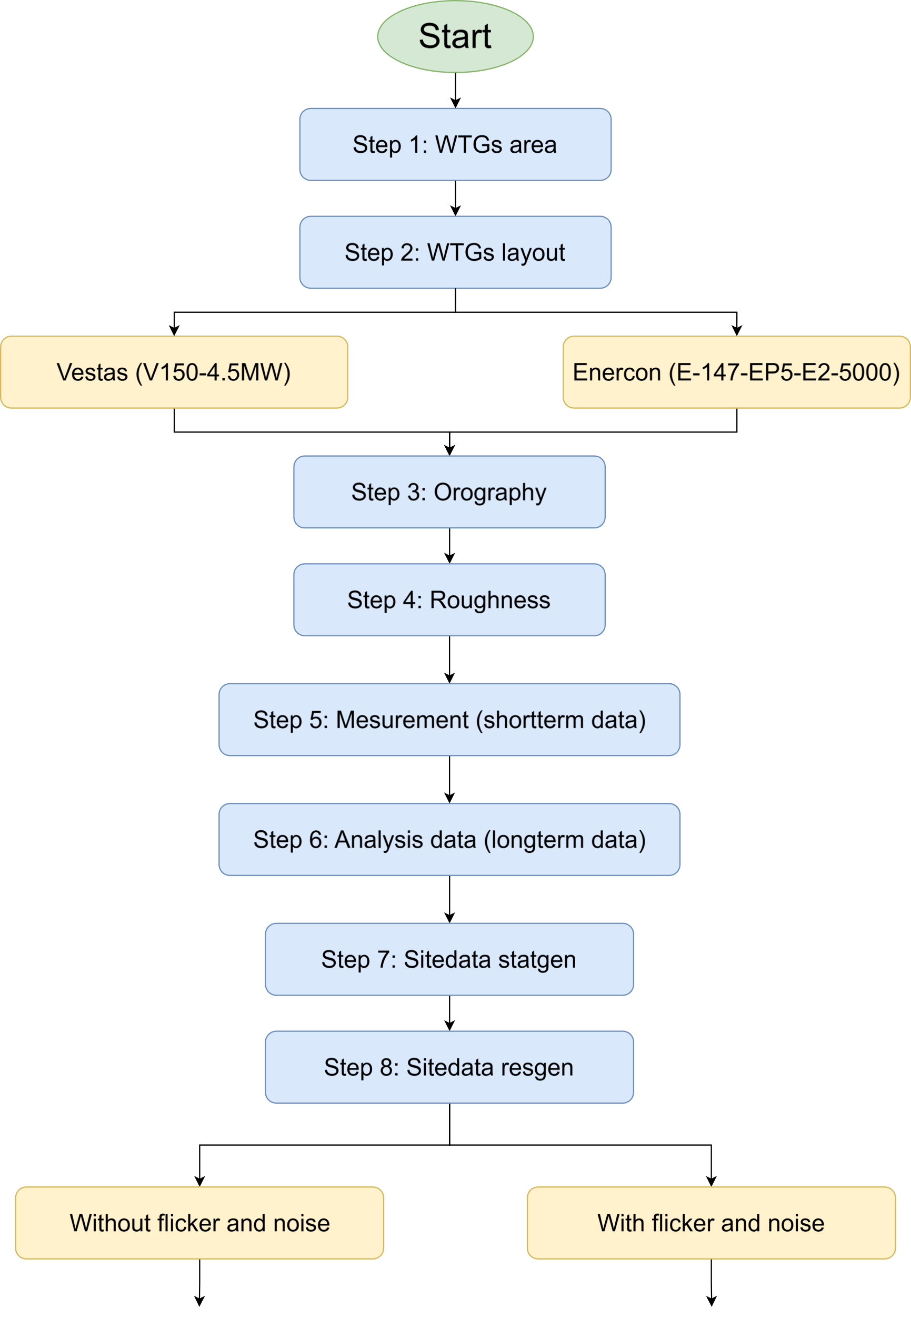

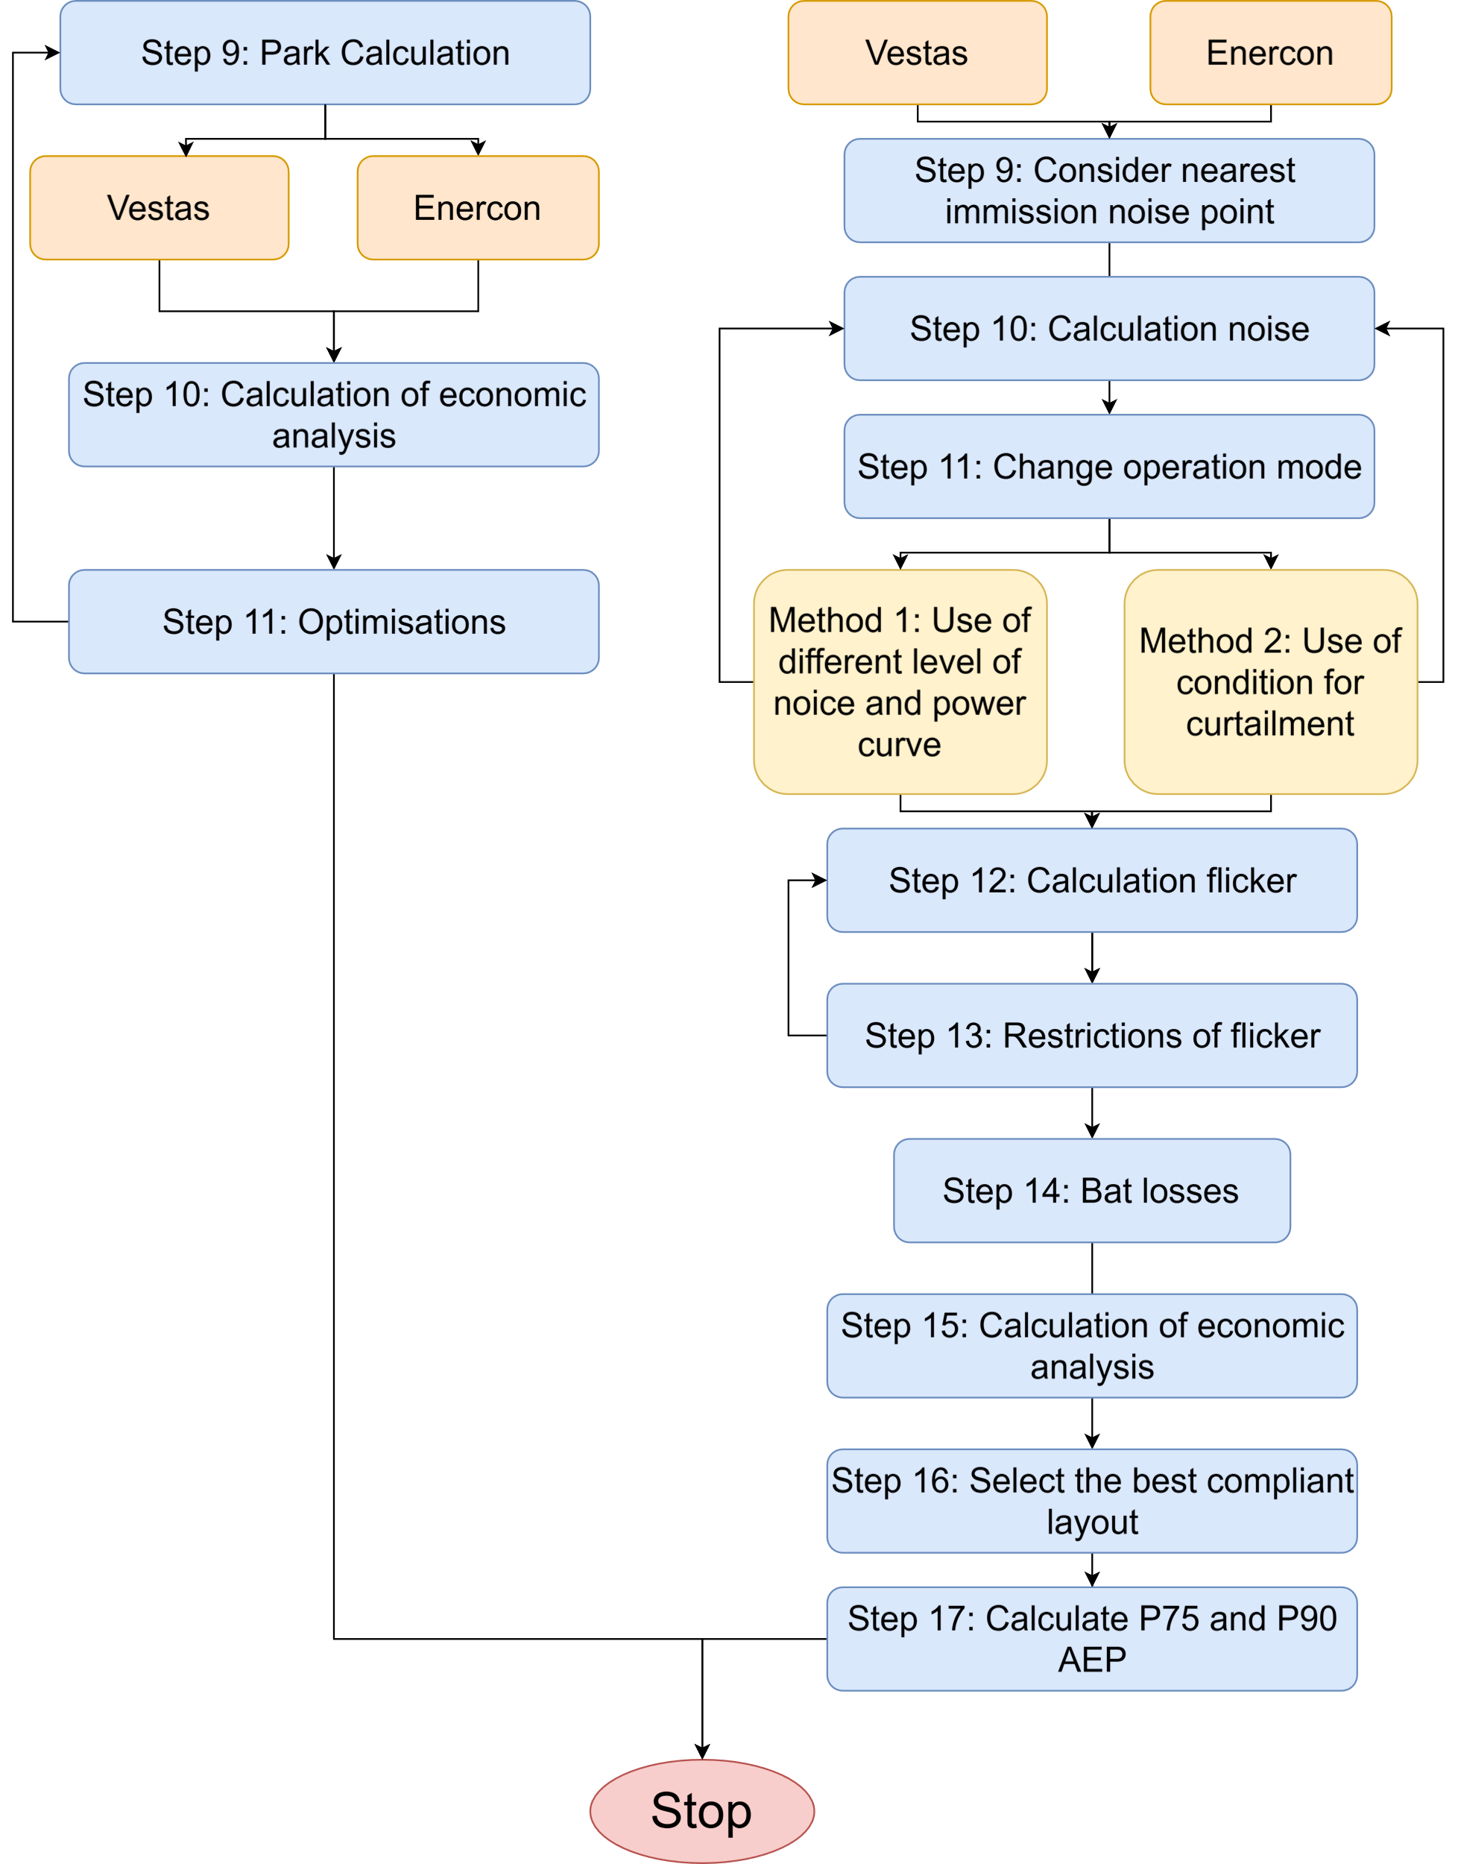

Reference: [2]

# Wind Farm Development

The wind area was already provided in the exam, so we directly imported it (see Figure 3.1).

Figure 3. 1: WTGs area

In our calculations, we considered both orography (see Figure 3.2) and roughness (see Figure 3.3), as they are crucial factors. Orography refers to the shape of the terrain, such as mountains and valleys, as well as elevation, which impact wind speed and direction. Roughness relates to the surface texture, including forests, buildings, and water bodies, which affect the wind profile near the ground. These factors play a significant role in accurately assessing wind conditions [3].

|  |  |
| --- | --- |
|  |  |
| Figure 3. 2: Orography | Figure 3. 3: Roughness |

The short-term LiDAR data was already provided in the exam, so we imported it into WindPro for further analysis. The long-term wind data was sourced online and imported into WindPro, which is ERA5(T) (See Figure 3.4).

After processing the data, we performed a comparative analysis using MCP (Measure-Correlate-Predict). This method helped in correlating the short-term LiDAR data with the long-term dataset ERA5(T), ensuring accurate wind predictions. The MCP process enhances the reliability of wind resource assessments by adjusting for variations and filling gaps in the data, ultimately improving the accuracy of energy yield estimations. We applied four different models for comparison, but the neural network model showed the closest resemblance to the long-term data (see Figure 3.5). Therefore, we selected this model as the most reliable for our analysis.(Annexture-A: MCP report)

|  |  |
| --- | --- |
|  |  |
| Figure 3. : Long term data ERA5(T) | Figure 3. : Long term and short term data comparisons |

To process and analyze the data, we used site data STATGEN (Annexture-B) to generate site-specific wind statistics and site data RESGEN to create resource grids based on the available data. Then we created a resource map (Annexture-C) using RESGEN data. These steps allowed us to evaluate the wind resource distribution across the study area (see Figure 3.6).

Figure 3. MCP output

## 3.1 Baseline layout without flicker and noise requirements

Before placing the wind turbines, we considered the wind direction, which is crucial for minimizing wake effects and optimizing energy production. This approach helps increase the Annual Energy Production (AEP) and enhances the overall profitability of the project by ensuring an efficient wind farm layout. As shown in Figure 3.7, the wind rose illustrates the predominant wind directions, and we specifically considered a **240-degree** wind direction for our analysis.

For the wind turbine layout, we considered both wake direction and wake distance to minimize energy losses and optimize efficiency. The wake direction was analyzed using an elliptical shape, where the major direction was set to **5R** and the minor direction to **3.5R** (see Figure 3.8). This approach ensures better spacing between turbines, reducing wake effects and improving overall energy output.

|  |  |
| --- | --- |
|  |  |
| Figure 3. : Wind rose | Figure 3. : Distance circle for wind turbine |

### 3.1.1 Layouts of Vestas V150-4.5MW HH125

As shown in Figure 3.9, the wind turbine layout features Vestas V150-4.5MW HH125 turbines. In our initial approach, we designed the wind farm layout with a total of six turbines, carefully considering wind direction and wake effects to maximize efficiency.

|  |  |
| --- | --- |
|  |  |
| Figure 3. 9: Six wind turbine of Vestas V150 – 4.5MW HH125 | Figure 3. 10: Five wind turbine of Vestas V150 – 4.5MW HH 125 |

As shown in Figure 3.10, the wind turbine layout features Vestas V150-4.5MW HH125 turbines. In our second approach, we designed the wind farm layout with a total of five turbines, carefully considering wind direction and wake effects to maximize efficiency. The wind turbine layout features Vestas V150-4.5MW HH125 turbines. In our third approach, we designed the wind farm layout with a total of seven turbines.

### 3.1.2 Comparison of different Layout of Vestas V150-4.5MW HH125

The AEP for the wind farm layout with **five** Vestas V150-4.5MW HH125 turbines is **82,810 MWh/year**, considering **4%** wake losses (see Figure 3.11). The calculated Net Present Value (NPV) is **9,354,499 euros**, and the Internal Rate of Return (IRR) is **14.52%**. The AEP for the wind farm layout with **six** Vestas V150-4.5MW HH 125 turbines is **98,137.1 MWh/year**, considering **5.1%** wake losses (see Figure 3.12). The calculated Net Present Value (NPV) is **10,573,478 euros**, and the Internal Rate of Return (IRR) is **14.32%**.

|  |  |
| --- | --- |
|  |  |
| Figure 3. 11: Wind park result for five Vestas wind turbines | Figure 3. 12: Wind park result for six Vestas wind turbines |

The AEP for the wind farm layout with **seven** Vestas V150-4.5MW HH 125 turbines is **112,331.2 MWh/year**, considering **6.8%** wake losses (see Figure 3.13). The calculated Net Present Value (NPV) is **11,187,243 euros**, and the Internal Rate of Return (IRR) is **14.01%**.

Figure 3. 13: Wind park result for seven Vestas wind turbines

The **seven-turbine** layout has the highest AEP **(112,331.2 MWh/year)** and NPV **(11,187,243 euros)**, but it also has the highest wake losses **(6.8%)** and a lower IRR **(14.01%)**, indicating a reducing over time return on investment.

The **five-turbine** layout has the highest IRR **(14.52%)**, but its NPV **(9,354,499 euros)** and AEP **(82,810 MWh/year)** are the lowest, meaning it generates less revenue overall.

The **six-turbine** layout provides a well-balanced solution, with a high AEP **(98,137.1 MWh/year)**, a competitive NPV **(10,573,478 euros)**, and a solid IRR **(14.32%)**, making it the most financially and technically viable choice. The **six-turbine** layout is the best option because it provides a strong balance betweenenergy production, wake losses, and financial performance.

### 3.1.3 Layout of Enercon E-147 EP5 E2 5000 HH 126

As shown in Figure 3.14, the wind turbine layout features Enercon E-147 EP5 E2 5000 HH 126 turbines. However, as discussed in the previous chapter, the layout with six wind turbines proved to be the most optimal for maximizing both the NPV and Internal Rate of Return IRR of the project.

Figure 3. 14: Six wind turbine of Enercon E147 EP5 E2 5000 HH 127

### 3.1.4 Commercial Evaluation of Wind Farm

**Commercial Evaluation of Vestas V150-4.5MW HH125 and Enercon E-147 EP5 E2 5000 HH 126 Wind Farm without Flicker and Noice Requirements**

|  |  |  |  |
| --- | --- | --- | --- |
|  | Vestas | Enercon | Unit |
| Wind farm installed capacity | 27 | 30 | MW |
| No. of WTGs | 6 | 6 |  |
| Lifetime | 35 | 35 | Years |
| Opportunity cost of capital | 11 | 11 | % |
| Remuneration rate | 65 | 65 | EUR/MWh |
| CAPEX |  |  |  |
| WTG Capex per MW | 1.05 | 1.05 | MEUR/MW |
| Other Capex per MW | 0.35 | 0.35 | MEUR/MW |
| Total CAPEX | 1.4 | 1.4 | MEUR/MW |
| OPEX |  |  |  |
| O&M | 80,000 | 80,000 | EUR/WTG/y |
| Gross AEP | 103,401 | 97246.7 | MWh/y |
| Total Loss | 11.6 | 11.1 | % |
| Cashflows | 37,800,000 | 42,000,000 | EUR |
| NPV | 10,573,478 | 3,502,121 | EUR |
| IRR | 14.32 | 12.00 | % |
| LCOE Calculation |  |  |  |
| PV CAPEX | 37,800,000 | 42,000,000 | EUR |
| PV OPEX | 4,718,072 | 4,718,072 | EUR |
| PV AEP | 898,656 | 849,622 | MWh |
| LCOE | 47.3 | 55 | EUR/MWh |
| NET P50 AEP | 91,426 | 86,438 | MWh/y |
| NET P75 AEP | 85,301 | 80,646 | MWh/y |
| NET P90 AEP | 79,724 | 75,374 | MWh/y |

Table 3. 1: Commercial Evaluation of six Vestas V150-4.5MW HH125 and Enercon E-147 EP5 E2 5000 HH 127 wind turbines

Based on the analysis of the two wind turbine layouts, the Vestas turbine layout **(27 MW)** appears to be the better choice compared to the Enercon layout **(30 MW)**. Although Enercon has a higher installed capacity, Vestas demonstrates a higher Net Present Value (NPV) of **10.57 million euros** compared to **3.50 million euros** for Enercon, along with a higher Internal Rate of Return (IRR) of **14.32%** versus **12.00%** for Enercon. Additionally, Vestas achieves a lower Levelized Cost of Energy (LCOE) of **47.3 euro/MWh**, making it more cost-effective compared to Enercon's **55 euro/MWh**. The superior financial metrics, lower LCOE, and better overall project returns indicate that Vestas is the more favorable choice for maximizing profitability and efficiency.

**Note: -**

Please find Annexture D (Excel and PDF) for Commercial Evaluation of Vestas V150-4.5MW HH125 Wind Farm without Flicker and Noice Requirements.

Please find Annexture E (Excel and PDF) for Commercial Evaluation of Enercon E-147 EP5 E2 5000 HH 126 Wind Farm without Flicker and Noice Requirements

## 3.2 Noise and Flicker Compliant Layout

Before evaluating noise and flicker impacts, we identified key areas, such as residential zones, schools, and other critical locations that could be affected by noise. These areas are highlighted as red-colored boxes in Figure 3.15. Defining these zones beforehand allowed us to accurately assess and mitigate potential noise and flicker effects during the planning process.

Figure 3. 15: Residencial and other area near to wind farm area

### 3.2.1 Noise

As shown in Figure 3.15, we identified the nearest emission points and conducted our initial simulation to generate a noise map. The results, presented in Figure 3.16, illustrate different noise zones: black represents areas with a noise sensitivity of **55 dB**, red corresponds to **45 dB**, and yellow indicates **33 dB**.

According to German regulations, the noise limit at night must not exceed **45 dB**. However, in our wind farm, this limit is exceeded at the nearest emission point. Due to the presence of multiple obstacles within the red zone, we implemented two mitigation approaches to address this issue, as outlined below.

Figure 3. 16: Noice levels Vestas layout

#### 3.2.1.1 Method 1: Use of different modes of operation of wind turbines

In our initial approach, we decided to operate the turbines in a lower mode, particularly those located near residential areas. To achieve this, we experimented with reducing the operational levels.

**Vestas V150-4.5MW HH125 Layout**

Our wind farm there are six turbines, and we identified that turbines 2, 3, 4, 5 and 6 had emission points classified within the red zone. To mitigate noise emissions, we first set these turbines to a higher level (Full performance) and ran a simulation. We then followed an iterative process with decreasing power modes of operation and adjusting as necessary, to ensure noise emissions remained within acceptable limits. (Annexture-F_First Simulation and Annexture-G_Optimized Map for Vestas)

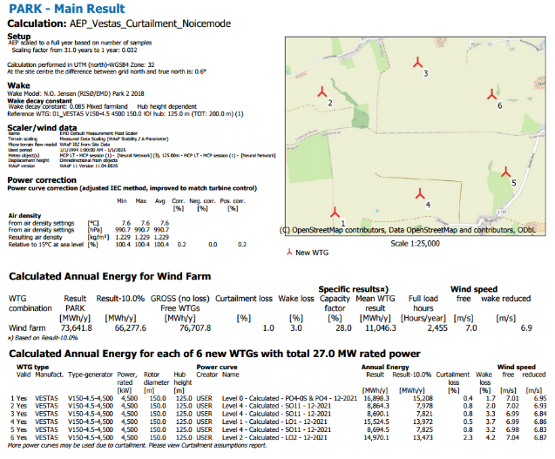

Figure 3. 17 : Vestas Noice mode result

|  |  |
| --- | --- |
|  |  |
| Figure 3. 18 : First Iteration of Operation modes | Figure 3. 19 : Final Iteration with optimized result |

**Enercon E-147 EP5 E2 5000 HH 126 Layout**

The same iterative optimization process was applied to the Enercon layout, as illustrated in Figure 3.20. In the Enercon layout, we identified that turbines 1, 4, 5, and 6 had emission points near residential areas. To mitigate this, we operated these turbines in lower power generation modes. (Annexture-H_First Simulation and Annexture-I_Optimized Map for Enercon)

Figure 3. 20 : Enercon Noice mode result

Figure 3. 21: Final Iteration with optimized result for Enercon layout

The impact of the process on AEP will be discussed in the following section 3.3.4.

#### 3.2.1.2 Method 2: Use of condition for curtailment

Another approach to mitigating the noise level issue is shutting down the turbines during nighttime hours, from 22:00 to 06:00. This measure aligns with the legal noise limit of 45 dB, which applies specifically at night when people are asleep. To comply with this regulation, we implemented curtailment on the turbines from January 1 to December 31, restricting their operation during these hours.

The effect of this process on AEP will be examined in Section 3.3.4.

Figure 3. : Noise curtailment

### 3.2.2 Shadow Flicker

The shadow effect, also referred to as "shadow flicker," happens when the rotating blades of a wind turbine create moving shadows on nearby buildings and properties. This phenomenon, caused by sunlight filtering through the blades, can be a concern for residents living close to wind farms, as it may lead to discomfort, distraction, or even health issues such as headaches or stress in some cases.

Germany enforces stringent regulations to reduce the impact of shadow flicker on nearby residents. The main requirements are as follows:

* **Annual Limit:** Shadow flicker must not surpass **30 hours per year** under worst-case scenarios.
* **Daily Limit:** The effect should not exceed **30 minutes per day** at any affected residence.

Therefore, conducting shadow flicker assessments is crucial, and we have incorporated this process into our wind farm planning, as outlined below.

To implement shadow flicker analysis, we utilized a tool called Shadow Receptor in the WindPro software. Our simulation was performed based on the worst-case scenario, and the results are presented in the figures below.

Figure 3. Shadow Flicker

After that, we conducted our simulation and obtained results for both layouts, as shown in Figures 3.24 and 3.25.

**Vestas (Annexture-J_ Shadow flicker for Vestas)**

Figure 3. 24 : Shadow flicker for Vestas layout

**Enercon (Annexture-K_ Shadow flicker for Vestas)**

Figure 3. 25: Shadow flicker for Enercon layout

As observed in the flicker map, shadow flickering in both layouts exceeds the **30-hour-per-year** limit. To address this, wind turbine operators must implement mitigation measures, such as automatically shutting down the turbines during critical periods.

However, due to time constraints, we were unable to incorporate this curtailment into the calculations for our layout.

### 3.3.3 Bats

Curtailment is generally implemented during periods of high bat activity, typically in the spring and autumn migration seasons when bats are more likely to fly near wind turbines. The main concern is the risk of collisions between the turbines and these species, especially during migration times or at specific times of the day when bats are most active. We implemented this curtailment as per the data given in the exam mentioned in Figure 3.24.

Figure 3. 26 : Implementation of Bat curtailment

### 3.3.4 Commercial Evaluation of Wind Farm

As mentioned in the previous sections, we carried out calculations for noise and bat curtailment. However, due to time constraints, we were unable to perform calculations for shadow flicker.

First, we will discuss the impact of different turbine operation modes and bat curtailment for both layouts. Then, we will address noise curtailment and bat curtailment, followed by a comparison of the effects of these two approaches on AEP and commercial considerations.

#### 3.3.4.1 Commercial Evaluation based Method 1: Use of different modes of operation of wind turbines and bat curtailment

|  |  |  |  |
| --- | --- | --- | --- |
|  | Vestas | Enercon | Unit |
| Wind farm installed capacity | 27 | 30 | MW |
| No. of WTGs | 6 | 6 |  |
| Lifetime | 35 | 35 | Years |
| Opportunity cost of capital | 11 | 11 | % |
| Remuneration rate | 65 | 65 | EUR/MWh |
| CAPEX |  |  |  |
| WTG Capex per MW | 1.05 | 1.05 | MEUR/MW |
| Other Capex per MW | 0.35 | 0.35 | MEUR/MW |
| Total CAPEX | 37.8 | 42 | MEUR/MW |
| OPEX |  |  |  |
| O&M | 80,000 | 80,000 | EUR/WTG/y |
| Gross AEP | 76,707.8 | 88,238.7 | MWh/y |
| Total Loss (Noise + bats) | 14.6 | 23.3 | % |
| Cashflows | 37,800,000 | 42,000,000 | EUR |
| NPV | 4,335,342 | 7,299,220 | EUR |
| IRR | 9.59 | 8.85 | % |
| LCOE Calculation |  |  |  |
| PV CAPEX | 37,800,000 | 42,000,000 | EUR |
| PV OPEX | 4,718,072 | 4,718,072 | EUR |
| PV AEP | 644,059 | 665,168 | MWh |
| LCOE | 66 | 70.2 | EUR/MWh |
| NET P50 AEP | 65,524 | 67,672 | MWh/y |
| NET P75 AEP | 61,134 | 63,138 | MWh/y |
| NET P90 AEP | 57,137 | 59.010 | MWh/y |

Table 3. 2 : Method 1: commercial Evaluation based on Noise modes and bat curtailment

Please find Annexture L (Excel and PDF) for Commercial Evaluation based Method 1: Use of different modes of operation of wind turbines and bat curtailment for Vestas Layout.

Please find Annexture M (Excel and PDF) for Commercial Evaluation based Method 1: Use of different modes of operation of wind turbines and bat curtailment for Enercon Layout.

#### 3.3.4.1 Commercial Evaluation based Method 2: Use of condition for curtailment for Noise and bat

|  |  |  |  |
| --- | --- | --- | --- |
|  | Vestas | Enercon | Unit |
| Wind farm installed capacity | 27 | 30 | MW |
| No. of WTGs | 6 | 6 |  |
| Lifetime | 35 | 35 | Years |
| Opportunity cost of capital | 11 | 11 | % |
| Remuneration rate | 65 | 65 | EUR/MWh |
| CAPEX |  |  |  |
| WTG Capex per MW | 1.05 | 1.05 | MEUR/MW |
| Other Capex per MW | 0.35 | 0.35 | MEUR/MW |
| Total CAPEX | 37.8 | 42 | MEUR/MW |
| OPEX |  |  |  |
| O&M | 80,000 | 80,000 | EUR/WTG/y |
| Gross AEP | 103,387.3 | 97,246.7 | MWh/y |
| Total Loss (Noise + bats) | 84.2 | 84.9 | % |
| Cashflows | 37,800,000 | 42,000,000 | EUR |
| NPV | 32,645,912 | 37,793,472 | EUR |
| IRR | -3.11 | -4.47 | % |
| LCOE Calculation |  |  |  |
| PV CAPEX | 37,800,000 | 42,000,000 | EUR |
| PV OPEX | 4,718,072 | 4,718,072 | EUR |
| PV AEP | 160,602 | 144,420 | MWh |
| LCOE | 264.7 | 323.5 | EUR/MWh |
| NET P50 AEP | 15,339 | 14,693 | MWh/y |
| NET P75 AEP | 15,244 | 13,708 | MWh/y |
| NET P90 AEP | 14,248 | 12,812 | MWh/y |

Table 3. 3 : Method 2: commercial Evaluation based on Noise and bat curtailment

Please find Annexture-N_ (Excel and PDF) for Commercial Evaluation based on Method 2 Use of condition for curtailment for Noise and bat_Vestas.

Please find Annexture-O_ (Excel and PDF) for Commercial Evaluation based on Method 2 Use of condition for curtailment for Noise and bat_Enercon.

Comparing both commercial evaluations, the first scenario (based on noise modes and bat curtailment) demonstrates a better financial performance than the second scenario (based on noise and bat curtailment). In the first case, the Net Present Value (NPV) is significantly higher for both **Vestas (4.34 million euros)** and **Enercon (7.30 million euros)**, whereas the second scenario shows negative NPV values, indicating financial losses. The Internal Rate of Return (IRR) is also more favorable in the first case (**9.59% for Vestas and 8.85% for Enercon**) compared to negative IRRs in the second scenario (**-3.11% and -4.47%**). Additionally, the Levelized Cost of Energy (LCOE) is significantly lower in the first scenario (**66 euro/MWh for Vestas and 70.2 euro/MWh for Enercon**) compared to much higher values in the second (**264.7 euro/MWh and 323.5 euro/MWh**), making the first approach more cost-effective. Although the Gross AEP is higher in the second scenario, the total losses due to noise and bat curtailment are significantly higher (**84.2% for Vestas and 84.9% for Enercon**) compared to the first scenario (**14.6% and 23.3%**), drastically reducing net energy output and financial viability. Thus, the first approach, which balances noise modes and bat curtailment, proves to be the more economically sustainable option.

# Recommendations for Future Work

Achieving an optimal design requires repeating this process and adjusting the variables. For example, changing the layout and location and number of wind turbines can lead to different results. However, the software itself also has an optimization option.

In our case, we aimed to achieve a layout with the best economic output within the four-hour exam duration.

For the design where noise, shadow flicker, and bat losses are critical factors, there are more adjustable parameters, such as the adjusting turbine's power mode, defining shutdown hours, and curtailment. Finding the optimal conditions in such cases requires more iteration and, consequently, more time.

# Conclusion

This study explored various wind farm layouts to optimize energy production while considering economic feasibility and regulatory constraints. Through iterative simulations and adjustments, we evaluated different configurations of Vestas V150-4.5MW and Enercon E-147 EP5 E2 5000 turbines. The results indicated that a six-turbine layout for Vestas achieved the best balance between energy yield, wake losses, and financial performance.

When incorporating constraints such as noise reduction, shadow flicker, and bat curtailment, we found that optimization became significantly more complex, requiring additional adjustments in power modes and operational hours. The financial analysis demonstrated that balancing noise modes and bat curtailment was the most viable approach, whereas excessive curtailment led to reduced profitability.

While our analysis was constrained by the exam’s time limit, future studies could refine these results by integrating advanced optimization algorithms and conducting more extensive simulations. Overall, this project highlights the trade-offs between maximizing energy output and complying with environmental and economic considerations in wind farm planning.

# References

|  |  |
| --- | --- |
| [1] | P. D.-I. D. Schlipf and D.-I. R. Steffen, *Wind Farm Control,* Flensburg: Lecture notes, 2024. |
| [2] | D. -M. E.-M. Nikolai and D. J. Winterfeldt, *Lecture notes "Advance Wind Farm Planning",* Flesburg, WS 2024/25. |
| [3] | M. C. R. F. Lasse Svenningsen, "Roughness in windPRO," EMD International A/S , Aalborg, 2021. |

# Appendix

|  |  |
| --- | --- |
| Annexture A | MCP CALCULATION |
| Annexture B | STATGEN |
| Annexture C | RESOURCE MAP based on RESGEN |
| Annexture D | Commercial Evaluation of Vestas V150-4.5MW HH125 without Flicker and Noice Requirements |
| Annexture D (Excel sheet) | Commercial Evaluation of Vestas V150-4.5MW HH125 without Flicker and Noice Requirements |
| Annexture E | Commercial Evaluation of Enercon E-147 EP5 E2 5000 HH 126 Wind Farm without Flicker and Noice Requirements |
| Annexture E (Excel sheet) | Commercial Evaluation of Enercon E-147 EP5 E2 5000 HH 126 Wind Farm without Flicker and Noice Requirements |
| Annexture F | DECIBEL Noice map for Vestas |
| Annexture G | DECIBEL Optimized Noice map for Vestas |
| Annexture H | DECIBEL Noice map for Enercon |
| Annexture I | DECIBEL Optimized Noice map for Enercon |
| Annexture J | Shadow Flicker for Vestas |
| Annexture K | Shadow Flicker for Enercon |
| Annexture L | Method 1 Use of different modes of operation of wind turbines and bat curtailment for Vestas |
| Annexture L (Excel sheet) | Method 1 Use of different modes of operation of wind turbines and bat curtailment for Vestas |
| Annexture M | Method 1-Use of different modes of operation of wind turbines and bat curtailment for Enercon |
| Annexture M (Excel sheet) | Method 1-Use of different modes of operation of wind turbines and bat curtailment for Enercon |
| Annexture N | Method 2 Use of condition for curtailment for Noise and bat for Vestas |
| Annexture N (Excel sheet) | Method 2 Use of condition for curtailment for Noise and bat for Vestas |
| Annexture O | Method 2 Use of condition for curtailment for Noise and bat for Enercon |
| Annexture O (Excel sheet) | Method 2 Use of condition for curtailment for Noise and bat for Enercon |